CTM-I Use Case

Role Maintenance

Version 0.1

Use Case Name | Role Maintenance
Actor | App Support User
Pre-conditions /Assumptions | User has Browser and is aware of the http path to the application.  User has successfully logged into the CTM-I application.  User has the right role to see the menu options.
Post Conditions | None
Screenshot | 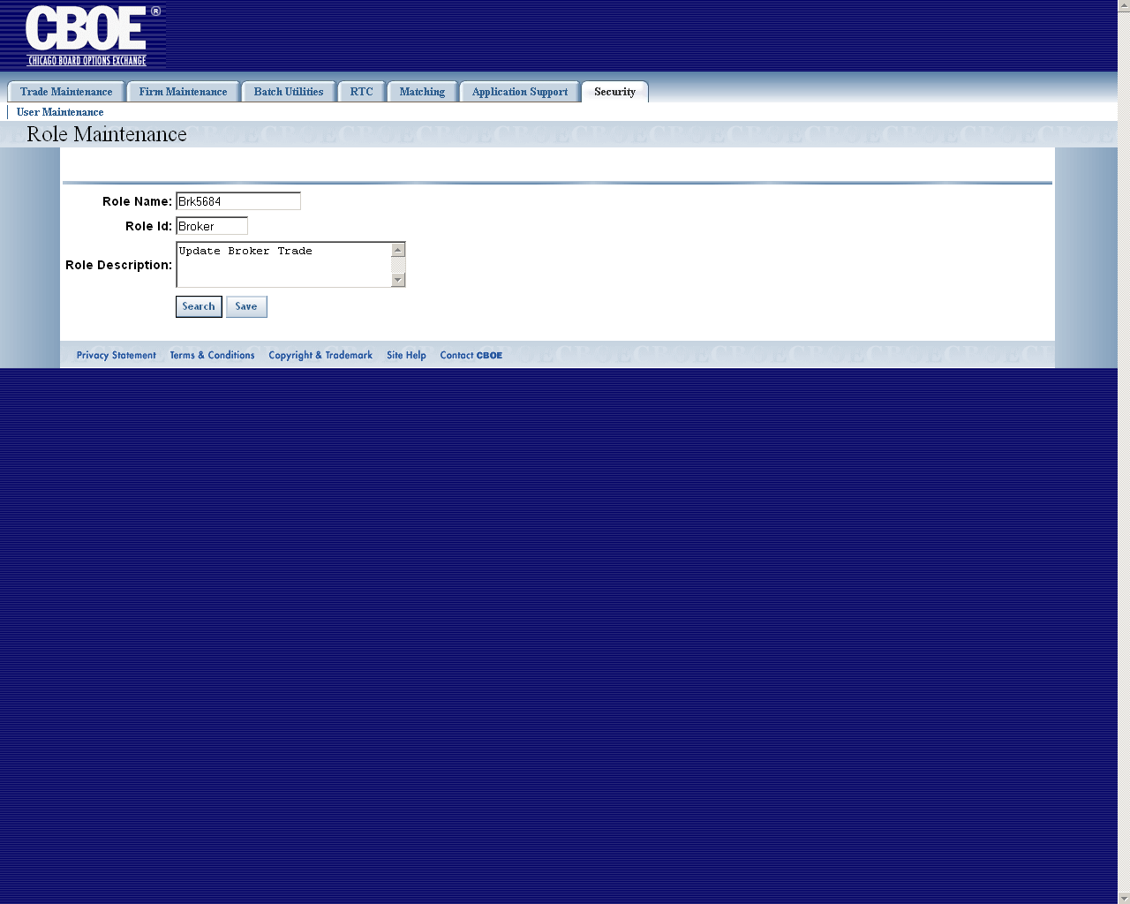
Flow of Events | - User selects “Role Maintenance” from the menu.  - The Role Maintenance screen appears  - The screen contains two action buttons:  - Search  - Search existing roles.  - Save  - Save the selected role.  - The search button will be available to submit the search  - The search will query our Role database and display the results in a scrollable pop-up window.  - The Pop-up window displaying the search results will contain the following fields  - Role Id  - Role Name  - Role Description  Along with the options to select a role or close the window.  - The user has the option of closing the pop-up window or selecting one of the roles. Closing the pop-up window will take the user back to the main Role Maintenance screen with no change to the screen. Selecting a role will take the user back to the main Role Maintenance screen with the selected role display.  - The save button will allow the user to save the selected role.
Alternative Path | 4.1.1 If the Database returns an error, or no results, the user will be informed of the error.

